**HOUSE RENTING APP Using MERN Stack**

***Screenshots of Installation and Executions***

**1. PRE-REQUISITES :**

Here are the key prerequisites for developing a full-stack application using Node.js, Express.js, MongoDB, React.js:

* **Vite:**

Vite is a new frontend build tool that aims to improve the developer experience for development with the local machine, and for the build of optimized assets for production (go live).

Vite (or ViteJS) includes: a development server with ES _native_ support and Hot Module Replacement; a build command based on rollup.

Installation

:

**npm**

**create**

**vite@latest**

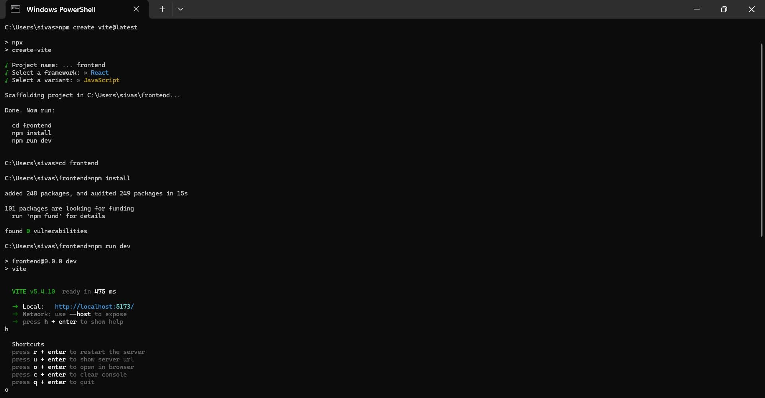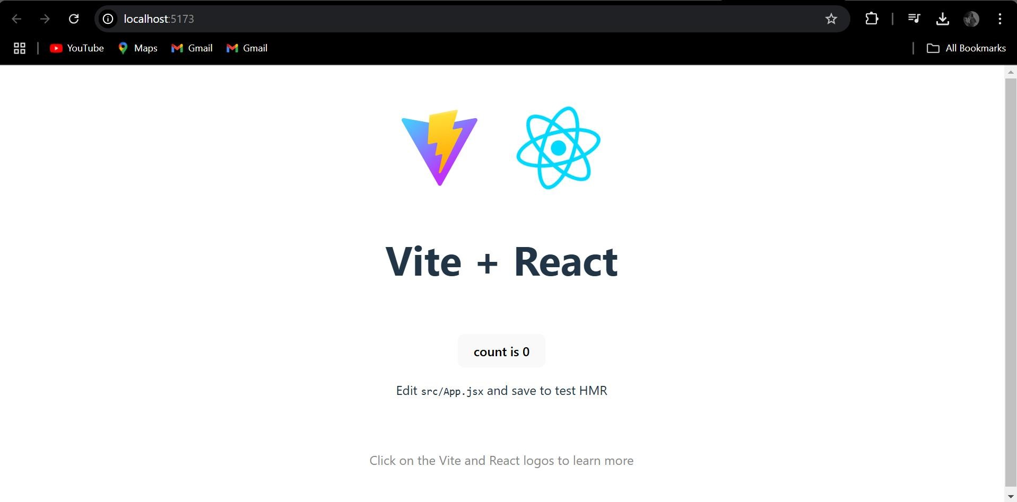

* **Node.js and npm:**

Node.js is a powerful JavaScript runtime environment that allows you to run JavaScript code on the server-side. It provides a scalable and efficient platform for building network applications. Install Node.js and npm on your development machine, as they are required to run JavaScript on the server-side.

# Download: <https://nodejs.org/en/download/>

Installation instructions: <https://nodejs.org/en/download/package-manager/>Run **“npm init”** to get default dependencies

* **Express.js:**

Express.js is a fast and minimalist web application framework for Node.js. It simplifies the process of creating robust APIs and web applications, offering features like routing, middleware support, and modular architecture. Install Express.js, a web application framework for Node.js, which handles server-side routing, middleware, and API development.

Installation: Open your command prompt or terminal and run the following command: **npm install express**

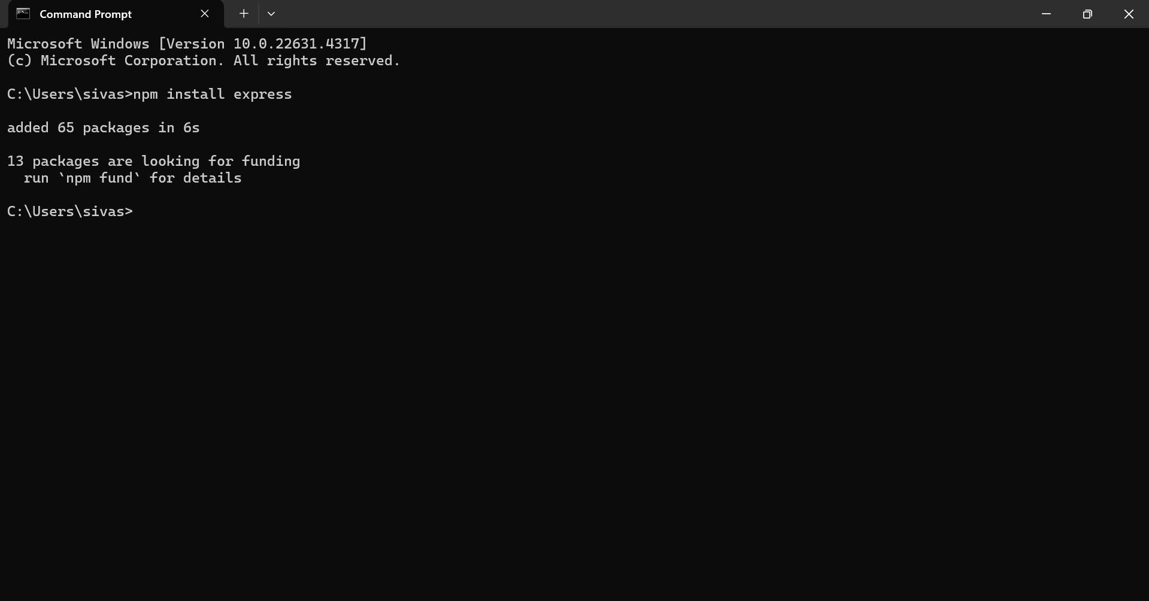

* **MongoDB:**

MongoDB is a flexible and scalable NoSQL database that stores data in a JSON-like format. It provides high performance, horizontal scalability, and seamless integration with Node.js, making it ideal for handling large amounts of structured and unstructured data.

Set up a MongoDB database to store your application's data.

Download: <https://www.mongodb.com/try/download/community>

# Installation instructions: <https://docs.mongodb.com/manual/installation/>

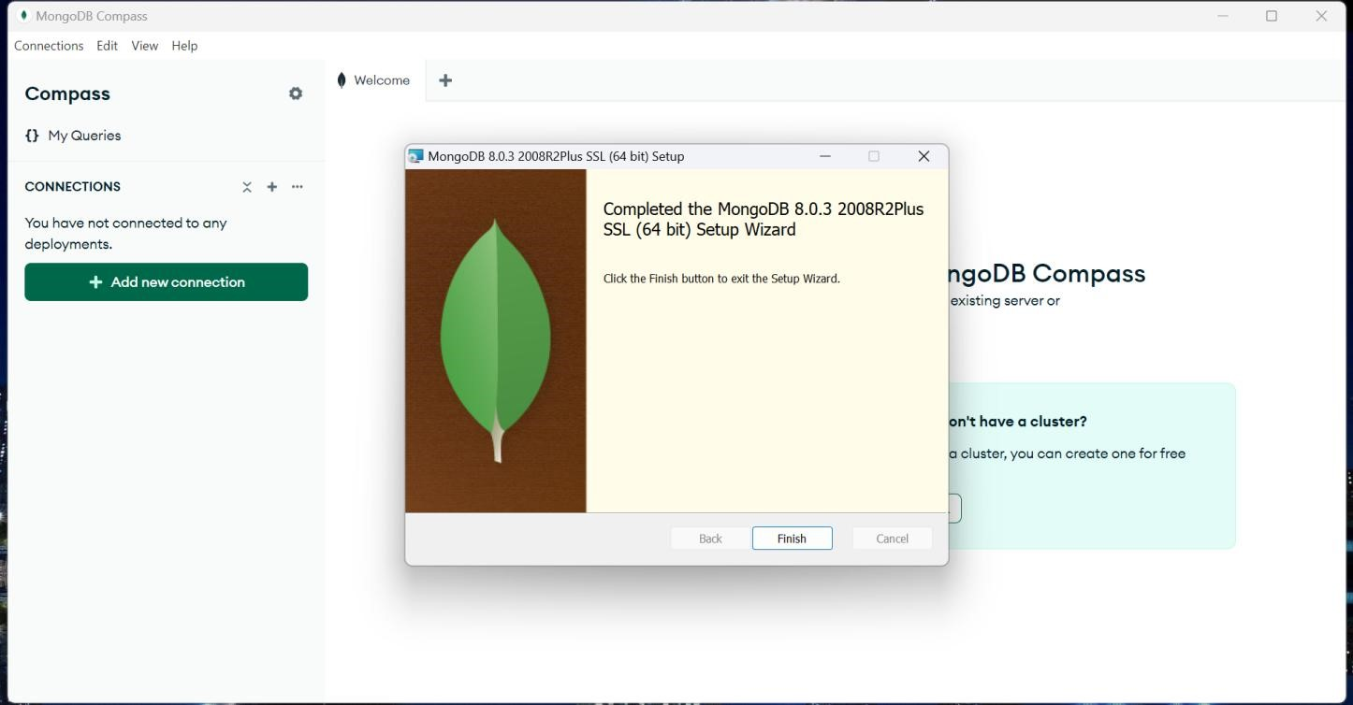

* **React.js:**

React.js is a popular JavaScript library for building user interfaces. It enables developers to create interactive and reusable UI components, making it easier to build dynamic and responsive web applications.

Install React.js, a JavaScript library for building user interfaces.

Follow the installation guide: <https://reactjs.org/docs/create-a-new-react-app.html>

* **HTML, CSS, and JavaScript**:

Basic knowledge of HTML for creating the structure of your app, CSS for styling, and

JavaScript for client-side interactivity is essential.

* **Database Connectivity**:

Use a MongoDB driver or an Object-Document Mapping (ODM) library like Mongoose to connect your Node.js server with the MongoDB database and perform CRUD (Create, Read, Update, Delete) operations.

* **Front-end Framework**:

Utilize React.js to build the user-facing part of the application, including entering booking room, status of the booking, and user interfaces for the admin dashboard. For making better UI we have also used some libraries like material UI and boostrap.

Install the required dependencies by running the following commands:

**cd frontend || npm install cd ../backend || npm install Start the Development Server:**

* To start the development server, execute the following command:

npm start

* The HRA app will be accessible at [http://localhost:5172](http://localhost:5172/)



The installation is successfully installed and set up the House renting app on your local machine. You can now proceed with further customization, development, and testing as needed.

* 1. **SCREENSHOTS**

**House renting website interface:**

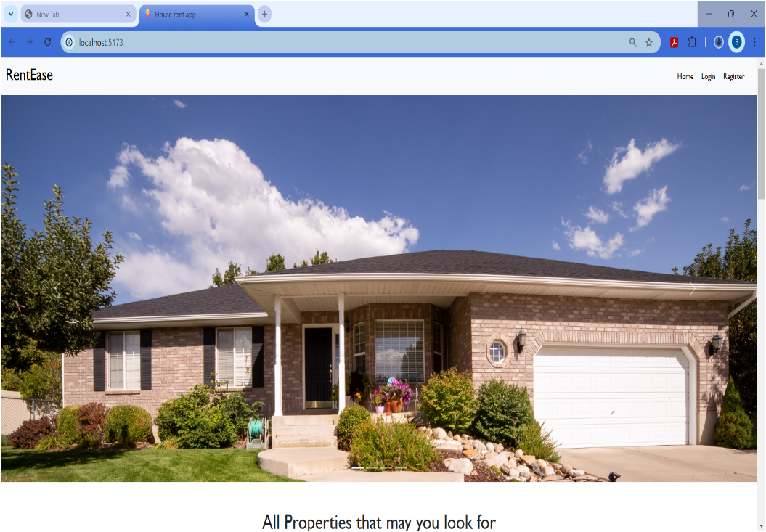

# Registration page:

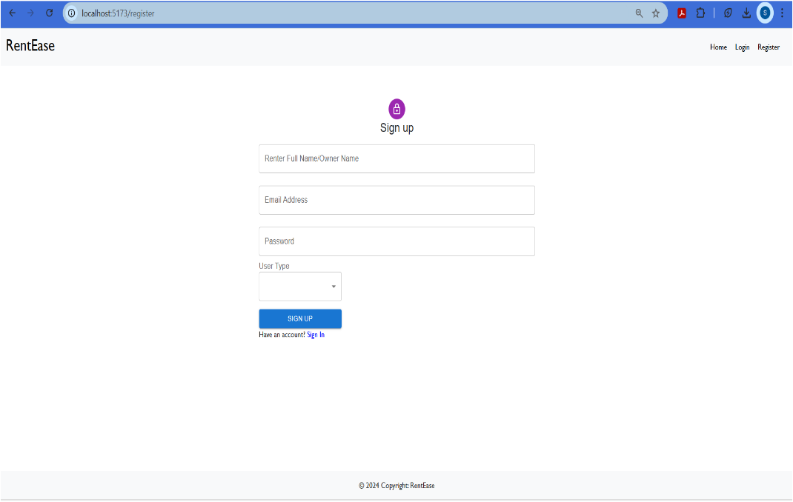

# Login page:

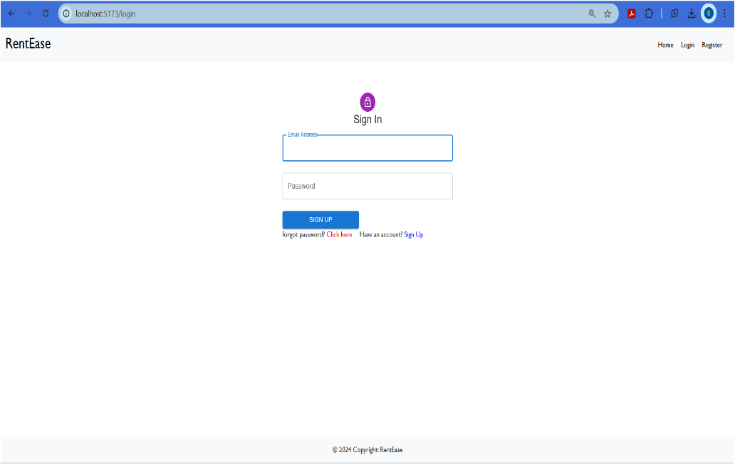

# Admin panel:

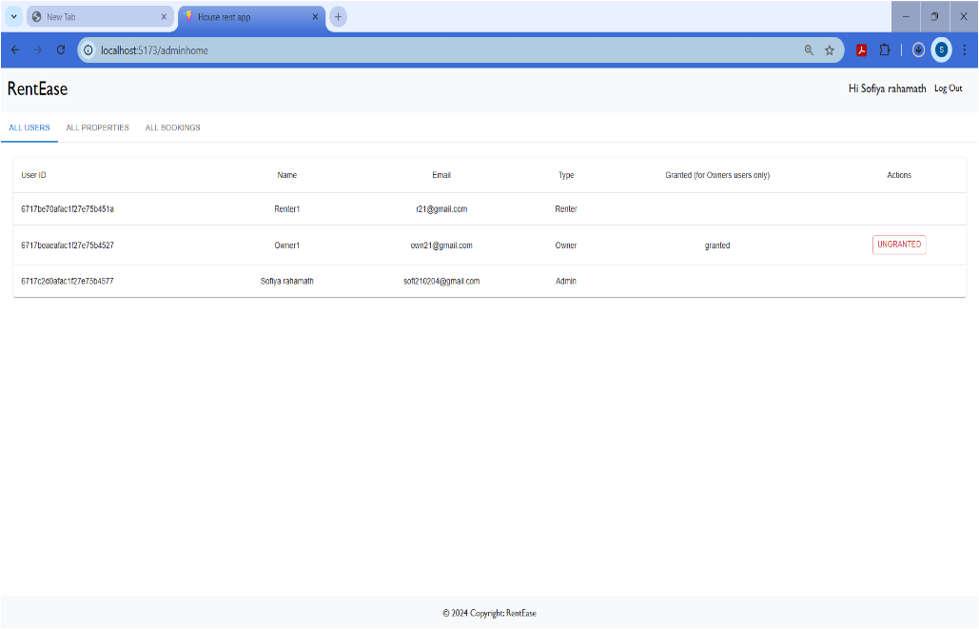

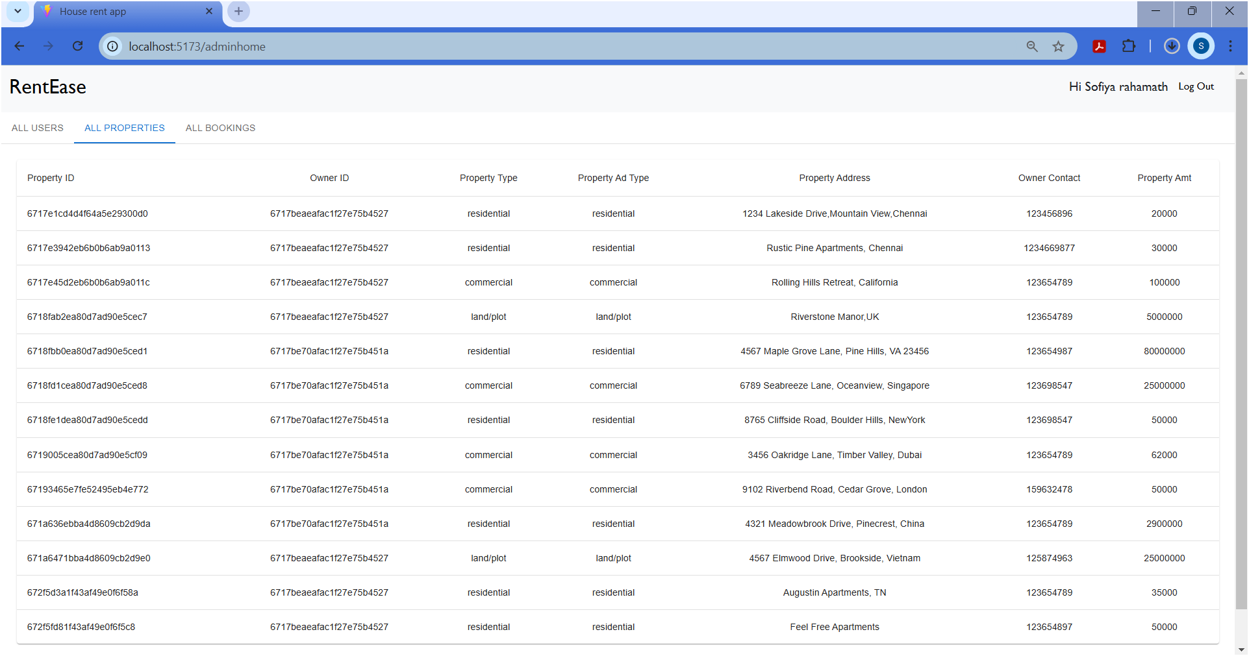

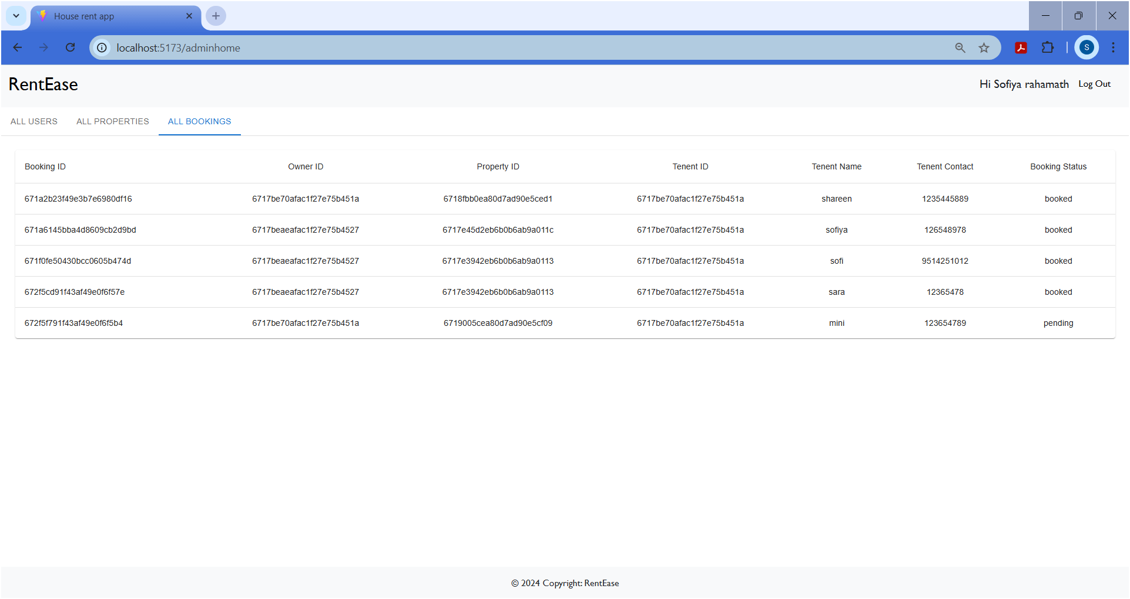

# Renter’s page:

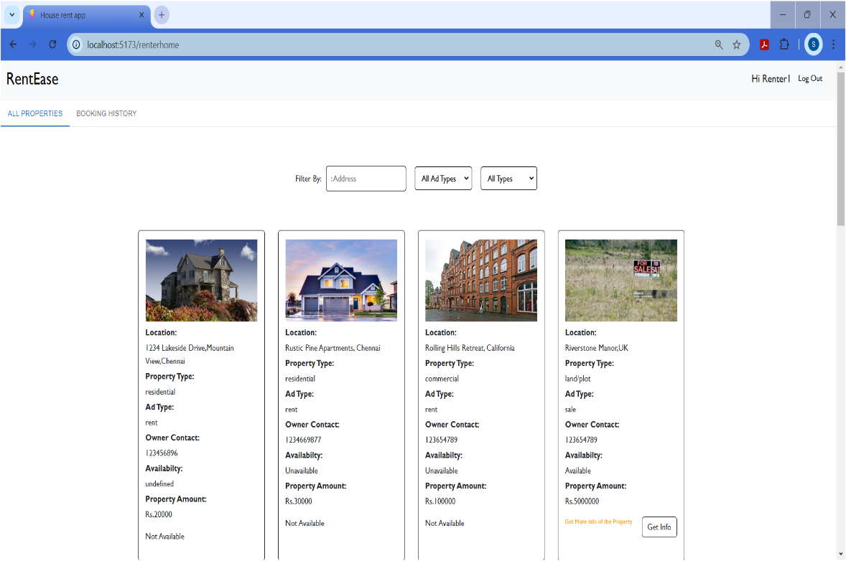

# Property Info:

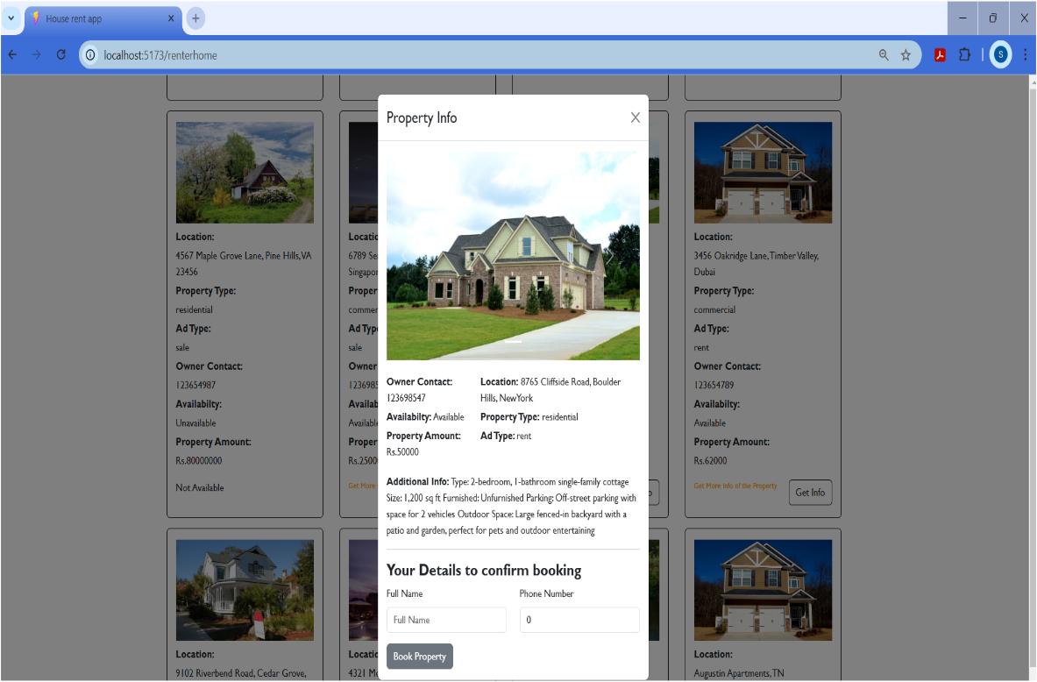

# Renter’s page History:

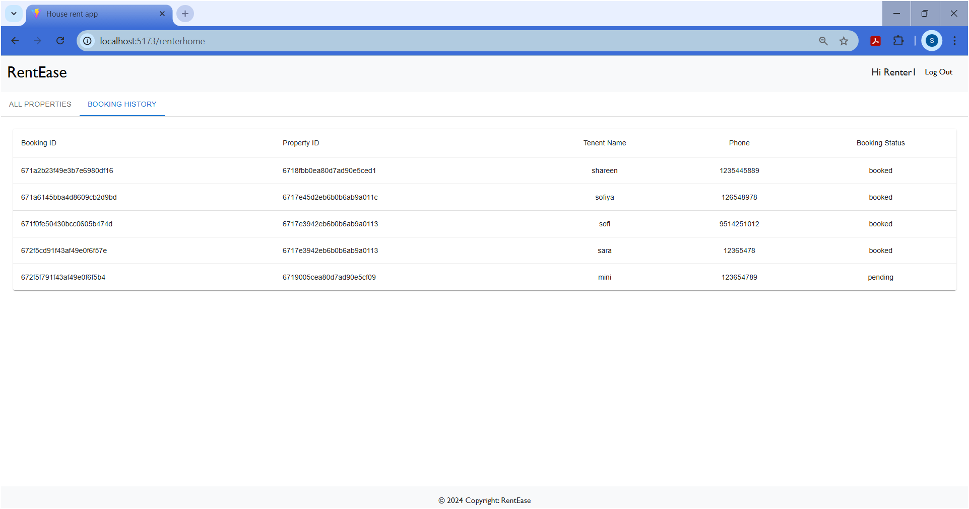

# Owner’s page:

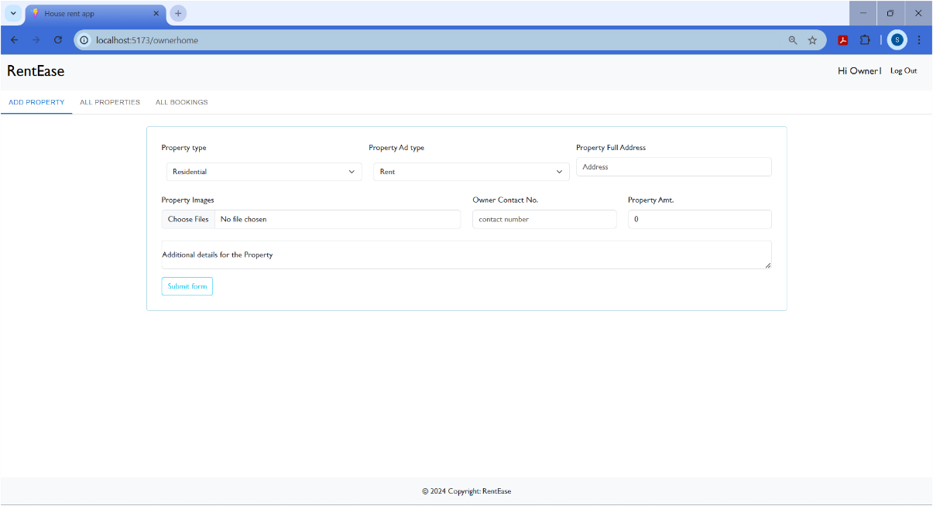

# Owner Properties Info:

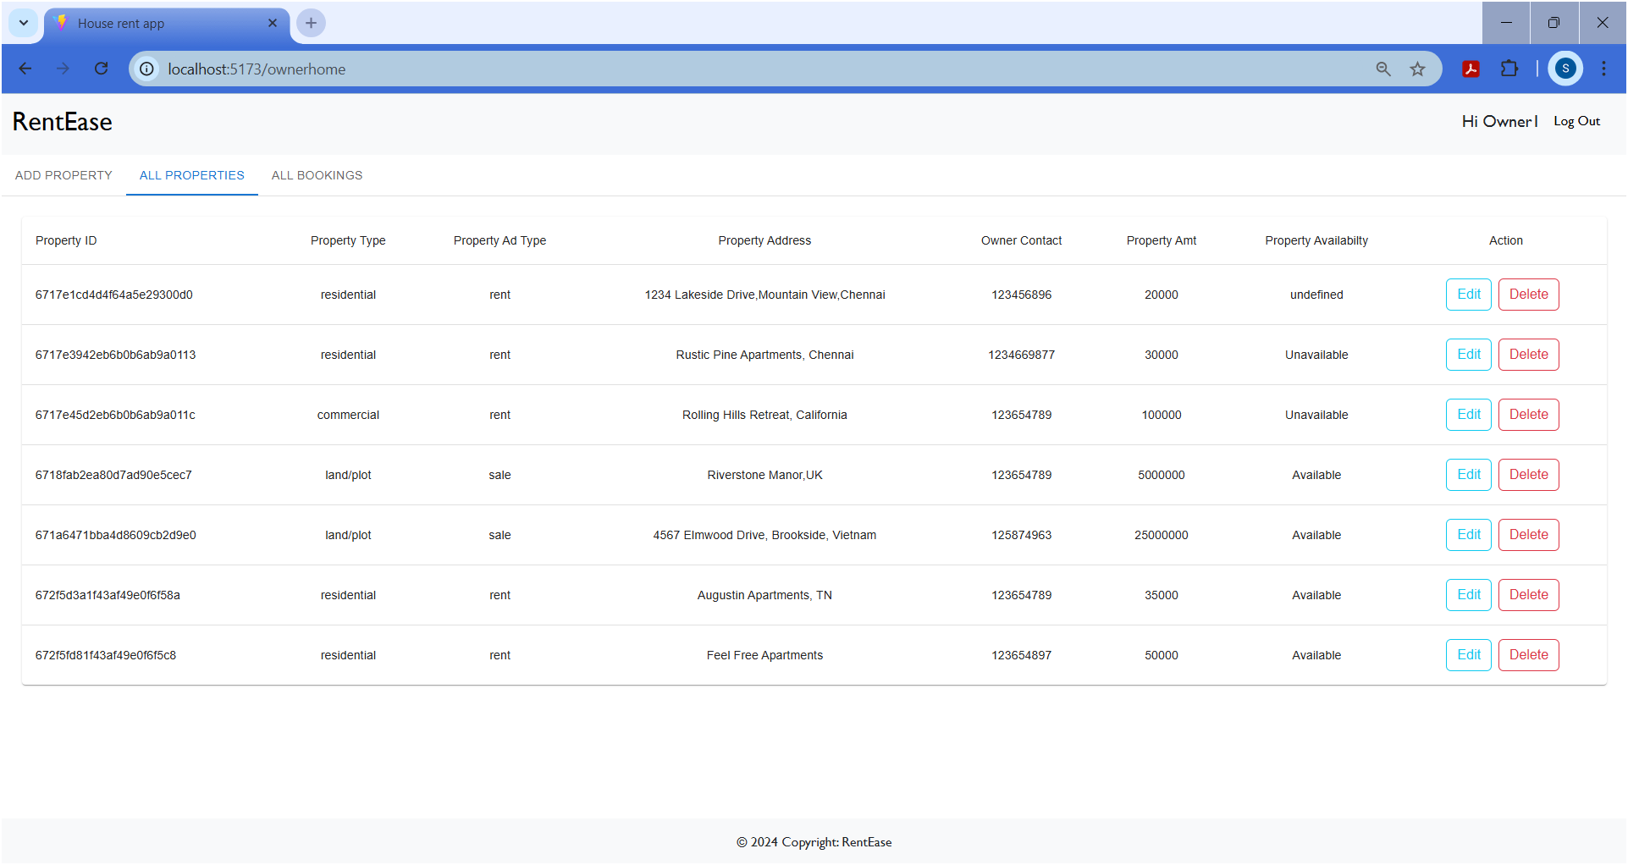

# All booking history:

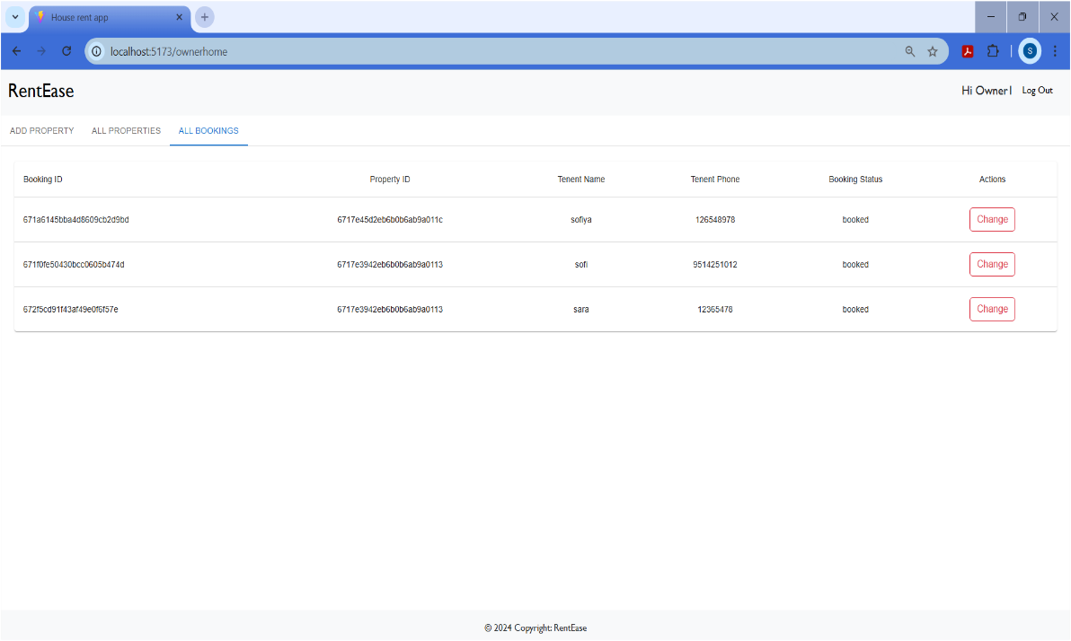

# Database Details

